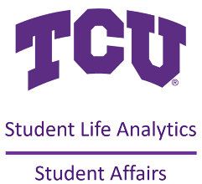
STUDENT LIFE ANALYTICS
WORKSHOP SCHEDULE
2023-2024

FALL 2023
September 7 Introduction to Baseline & Planning
Computer Training Room in Library (Rm 3202)
October 5 Developing Intentional Learning Outcomes for Student Affairs
Student Success Conference Room (Rm 018)
November 2 Program Evaluation: Variations on a Theme
Student Success Conference Room (Rm 018)

SPRING 2024
January 11 Conducting Focus Groups
Student Success Conference Room (Rm 018)
February 8 Constructing an Effective Survey/Evaluation
Computer Training Room in Library (Rm 3202)
March 7 Equitable Assessment
Student Success Conference Room (Rm 018)
April 4 End of Year Reports Made Easy
Computer Training Room in Library (Rm 3202)

All workshops are scheduled from 2:00pm to 3:30pm

